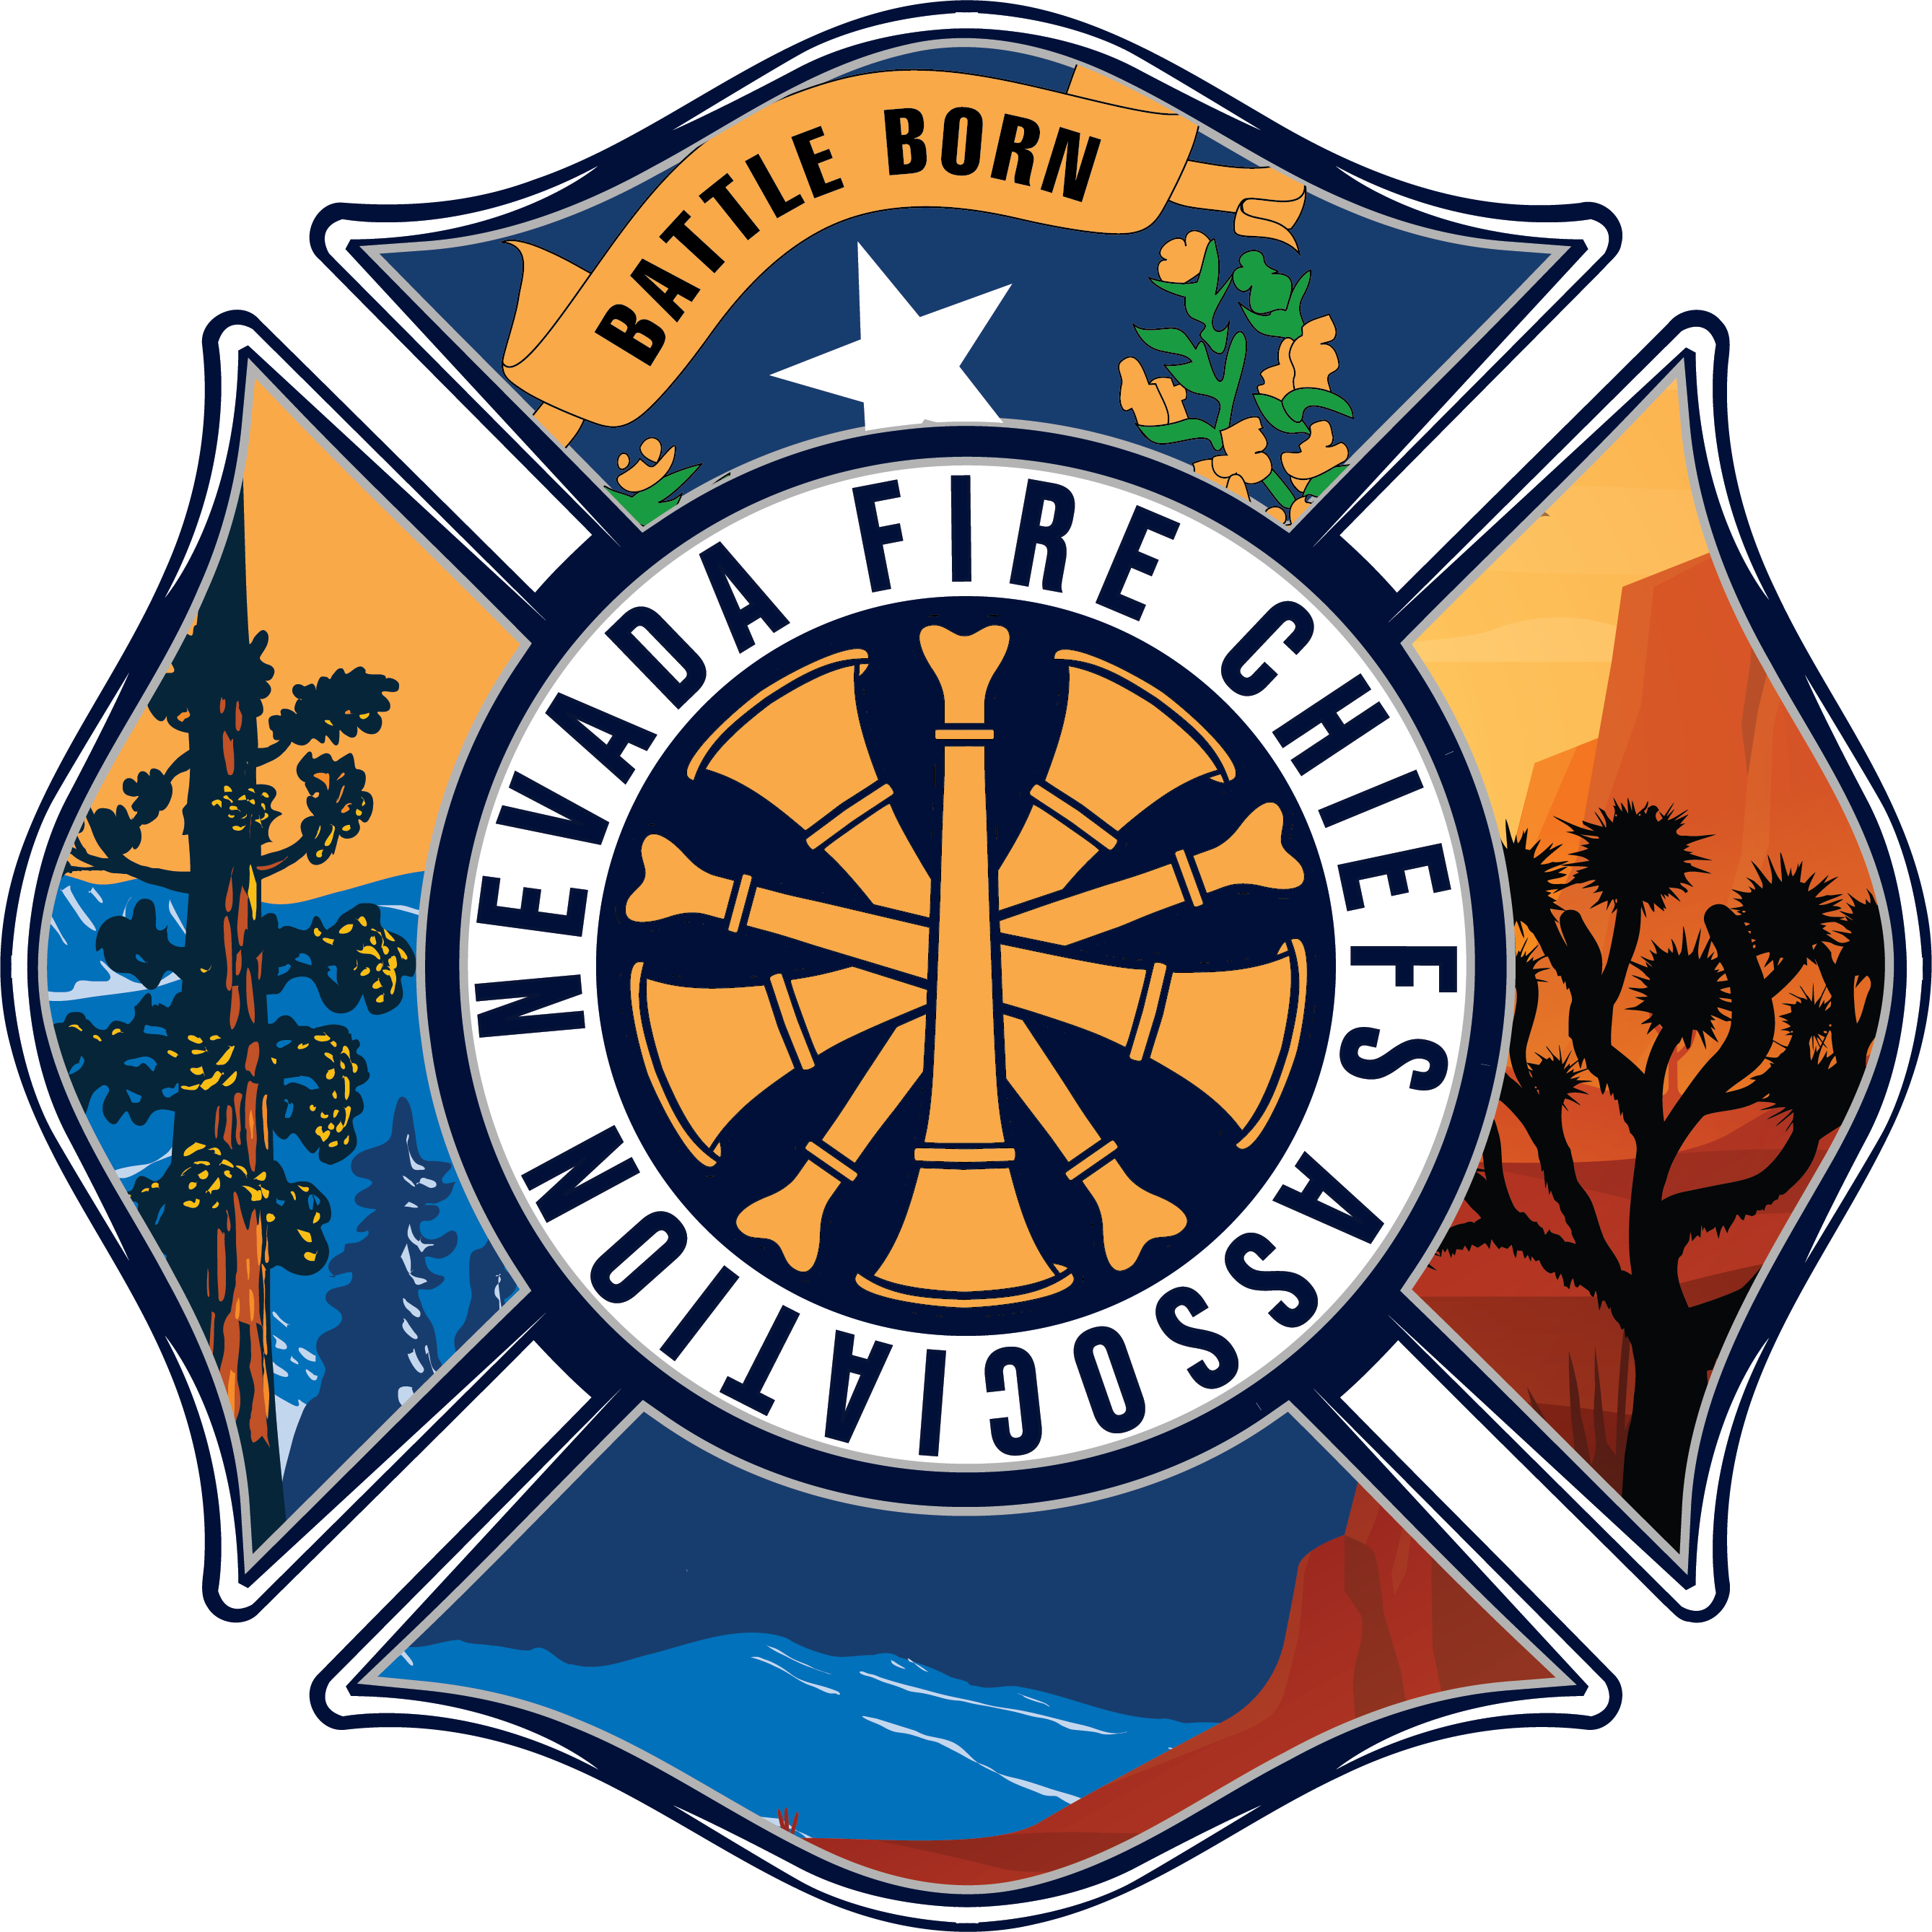

2025-2026 NFCA Wildfire Risk Reduction Program
Funding Application

Application due to NFCA by Friday, March 14, 2025
Application checklist must be submitted with funding application

General Information
Project type  Use separate applications for each project. | Education & Outreach Activities (award up to $10,000)
Project type  Use separate applications for each project. | Hazardous Fuels Reduction Treatment (award up to $75,000)
Project Title
Amount Requesting | $
Applicant Organization

Applicant Address | Street:  City:  State:  Zip:
Applicant Contact | Name:  Title:  Phone:  Email:
Organization Type | County Government  Municipality  Political Subdivision (e.g. Soil & Water Conservation District)  Native American Tribe  Non-Profit Organization
Federal EIN/UEI
Does your organization receive more than $500,000 in federal funding on an annual basis? | Yes  If yes, applicants must submit a copy of their audit with this application.  No
Has this project been submitted to, or will be submitted to, other funding sources? | Yes No  If yes, grant year(s):  Name of project(s) funded:  Amount(s): $
Project location  https://www.topozone.com/ | Project coordinates/central area location:  Latitude . N Longitude . W  Shape files:  Yes, attached (Required for, fuels reduction projects and ground disturbing education & outreach projects)  No, not required
District information  https://www.leg.state.nv.us/Division/Research/Districts/Reapp/2021/  https://nvlcb.maps.arcgis.com/apps/instant/lookup/index.html?appid=0815e77623f04028993e9f3ecc56174e | Congressional district number:  State Senate district number:  State House of Representatives district number:
Identify the most current CWPP/Hazard Mitigation Plan update for your community, county or tribe. | CWPP/Hazard Mitigation Plan title:  Approval date:  Provide a link to the most recent CWPP/Hazard Mitigation Plan:
Check all boxes that relate to your project objectives.  National Cohesive Strategy information: https://www.forestsandrangelands.gov/strategy/thestrategy.shtml | Community Wildfire Protection Planning  Community Outreach &/or Education  Defensible Space  Protecting Watershed  Ecosystem Restoration  Protect Threatened & Endangered Species Habitat  Forest Health  Reduce Invasive Species  Fuel Reduction  Wildland Urban Interface (WUI)  Rangeland Health  Improves Responses to Wildfire  Maintains Previous Investments  Aids in Reducing Large Fire Costs  Provides for Firefighter Safety
Communities at Risk  https://forestry.nv.gov/fan/cwwp-publications |  | List Communities at Risk.  High:  Medium:  Low:  List additional communities affected, but not on list (if applicable):
Does this project provide a direct mutual benefit to other initiatives by non-profit/state/federal entities such as BLM, Nevada Division of Forestry, Nevada State Land Office or US Forest Service? |  | Yes No  Is yes, list agency(s):
Community, local, state, and federal partners and their role in the project |  | Community:  Local government:  State:  Federal:  Attach letters of commitment from each partner identifying role, responsibility and cost sharing arrangement (if any).

Project Timeline
Project Tasks  Provide a brief description of the project’s sequential tasks. | Time Frame  Provide duration of time for each task within the 12-month grant period. | Responsible Party  Grant applicant or appropriate partner.
Add lines as needed

Budget Summary
Summarize the project budget:
- Provide a clear understanding of your request.
- Provide specific information on personnel costs.
- Note if you expect to receive any income from your project (firewood sales, etc.).

Budget Spreadsheet |  | These expenses may qualify as cost share/match. See OMB circulars A110 & 102.
Budget Spreadsheet | Grant Funds | Applicant Contribution | Partner/Third Party  Contribution | Total Project Cost
Personnel
Travel
Equipment
Supplies
Contractual
Other (specify)
Total | $ | $ | $ | $
If there are fringe benefits or indirect charges that you’d like to include, enter as “other” and specify type.

Education & Outreach Applicants ONLY
Project Description  Provide:  - Clear scope of work  - Scale of project  - Need for education  - Target audience  Describe:  - Community events  - Community economic benefits  - Reasons for purchasing/developing products  - Understanding of special considerations  - How you’ll survey participants, monitor effectiveness and collect data | Narrative:
Previous Experience  - Describe previous experience for this type of project.  - Note successes and failures. | Narrative:  Web link to previous experience documentation:  (If web link not available, attach examples supporting previous experience.)
Meetings/Activities/Trainings | Number of activities planned:  List of types of meetings or activities:  Anticipated number of attendees for project duration:
Products Developed or Purchased  Provide specifics on the types of products such as green waste roll-off containers, billboard rental, etc.  Include marketing materials you intend develop or purchase with anticipated cost per item, number of items printed such as brochures, booklets, advertising, and television spots, etc. | List types of products you plan to purchase or develop:  How many products do you plan to purchase or develop?

Hazardous Fuels Treatment Applicants ONLY
Project Description  Provide:  - Clear scope of work  - Project need  - Type of project: maintenance or retreatment of area  - Type and number of landowners benefited  Describe:  - Specific treatment method(s) and note why the method is appropriate and consistent with other prescriptions in the area  - Vegetation type  - Community notification/outreach  - Community economic benefits  - Understanding of clearance requirements, etc. |  | Narrative:  - Attach photographs of project area.  - Attach project area map(s).  - Provide electronic shape files. (If available)
Previous Experience  - Describe previous experience for this type of project.  - Note if this area has been previously treated?  - Note successes and failures. |  | Narrative:  Web link to previous experience documentation:  (If web link not available, attach examples supporting previous experience.)
Treatment Acres
(Total acres treated will exceed project footprint if more than one type of treatment.)
Treatment Type  (e.g. cut, treat, grazing) | Vegetation Type |  | # of Acres | Cost
Add lines as needed |  |  | Total #: | Total: $

Example:
Project footprint is 50 acres/total treated acres is 75 acres.
Treatment type | Vegetation type | # Acres
Cut | P/J | 25
Grazing | Grass | 50
Total treated acres: |  | 75 acres

Contact Kelli Baratti at (775) 720-9874 or grants@nvfirechf.org if you have any questions.

